SL1: Deployment Automation Version 103.1
This PowerPack provides deployment settings and best practices using automation within the SL1 platform.

PowerPack Content
- 1 x Example Credential
- 1 x Run Book Schedule
- 1 x Actions
- 1 x Automations

PowerPack Installation
To install the PowerPack:
- Download the PowerPack
- Go to the PowerPack Manager page (System > Manage > PowerPacks).
- In the PowerPack Manager page, click the Actions button, then select Import PowerPack.
- The Import PowerPack dialog box appears:

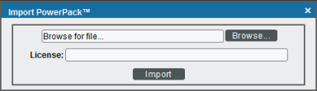

- Click the [Browse] button and navigate to the PowerPack file.
- When the PowerPack Installer modal page appears, click the Install button to install the PowerPack.

Prerequisites
Before you can deploy the SL1: Deployment Automation PowerPack, you must have the following information:
- IP addresses and SSH passwords of all Databases or All-In-One if not SaaS
- If using multiple databases, port 22 must be open between databases to use SSH option
- ScienceLogic Billing server information (billing server user, billing server password and billing server offset)

Creating a SOAP/XML Credential
To execute the SL1: Deployment Automation Run Book Automation, you must first create a SOAP/XML credential.
- Go to the Credential Management page (System > Manage > Credentials).
- Locate the “SL1: Deployment Automation Example” credential, and then click its wrench icon (). The Edit SOAP/XML Credential modal page appears:

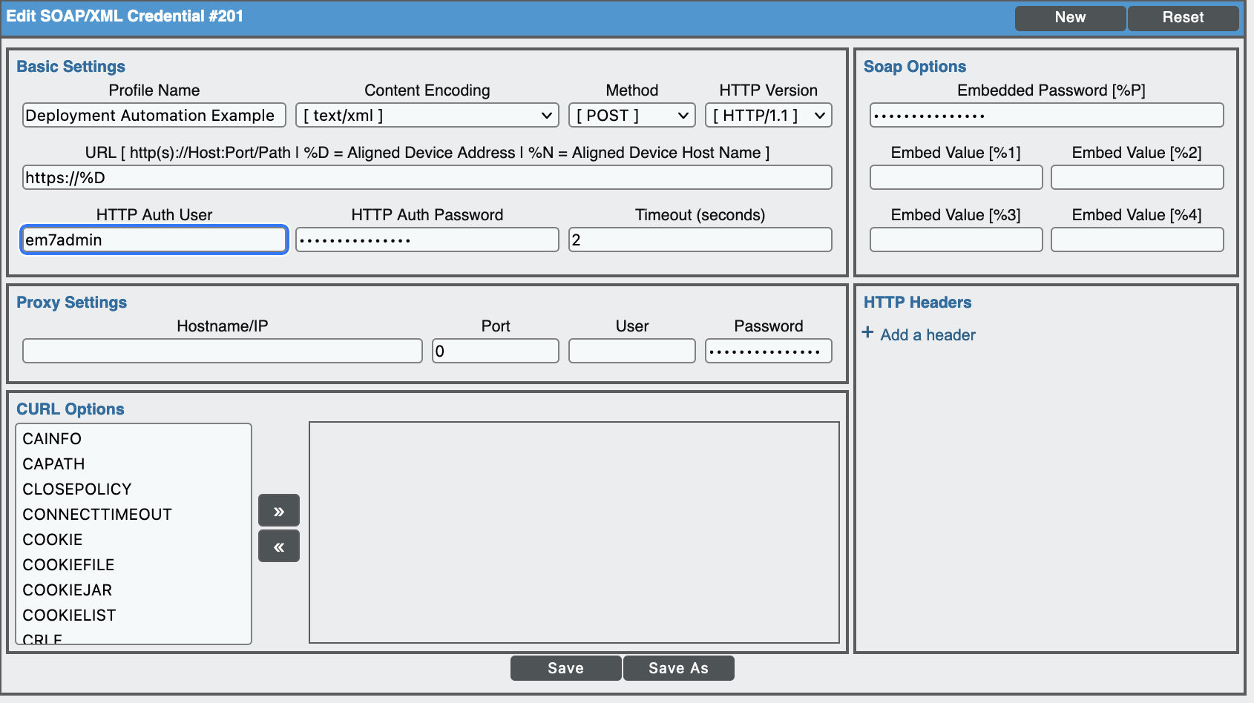

- Complete the following fields:
- Profile Name. Type a name for the credential.
- Content Encoding. Select text/xml.
- Method. Select POST.
- HTTP Version. Select HTTP/1.1.
- URL. Type https://%D
- HTTP Auth User. Leave this as em7admin.
- HTTP Auth Password. Type the em7admin user SSH account password for the primary Database or All-In-One.
- Timeout (seconds). Type "2".
- Embedded Password [%P]. Type the em7admin user SSH account password for the Disaster Recovery Database if applicable.
- Proxy Settings Password. Type the em7admin user SSH account password for the Secondary High Availability Database if applicable.
- Click the Save As button.

Creating an SL1 Virtual Device for Automation
The automation engine requires a device to be aligned to a Run Book Automation. With, you must create a virtual device to align.
To create a virtual device:
- Go to the Device Manager page (Unified Interface: Devices > Device Manager, Classic Interface: Registry > Devices > Device Manager).
- Click the Actions button, then select Create Virtual Device. The Virtual Device modal page appears:
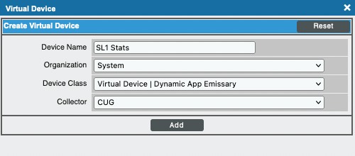
- Enter values in the following fields:
- Device Name. Enter a name for the device. For SaaS Deployments use “SL1 Stats”.
- Organization. Select the “System” organization.
- Device Class. Select Virtual Device | Dynamic App Emissary.
- Collector. Select a collector group, one may need to be created. If SaaS select the “Self-Monitoring Collector”.
- Click the Add button to create the virtual device.

Configuration
To modify the parameters for the "SL1: Deployment Automation" Run Book Action:
- Go to the Action Policy Manager page (Registry > Run Book > Actions).
- Click the wrench icon () for the "SL1: Deployment Automation" Run Book Action.
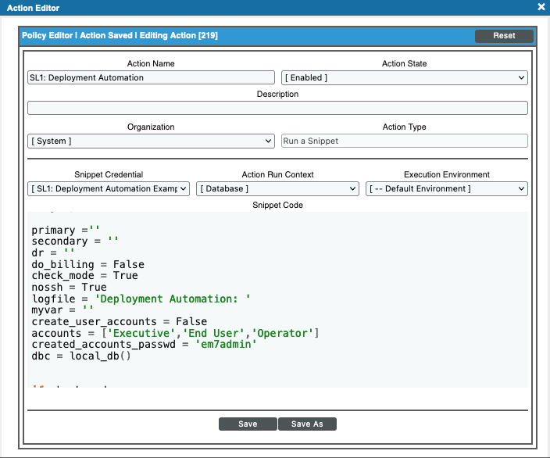
- In the Snippet Code field, locate and edit the following lines:
primary =''
secondary = ''
dr = ''
do_billing = False
check_mode = True
nossh = True
create_user_accounts = False
accounts = ['Executive','End User','Operator']
created_accounts_passwd = 'em7admin'

- primary. This field is required for non-SaaS deployments, must be the IP address of the primary database or All-In-One.
- secondary. (optional) Must be the IP address of the secondary High Availability database.
- dr. (optional) Must be the IP address of the Disaster Recovery database.
- do_billing. True or False. If True, you must fill out the following lines:
  - buser -billing server user
  - bpsswd - billing server password
  - boffset - offset of the billing server, place value inside int function ex. int(9)
- check_mode. True or False. This mode will test the SSH connection(s) between database servers, run SELECT queries to give current values before executing UPDATE queries, and provide query result output before being changed all if set True. A False value will execute changes listed in “Notes” section 5 below.
- nossh. True or False. Set to True if running on a SaaS deployed environment, cloud base deployment or if you wish to bypass SSH commands. Note: If this setting is enabled, no credential needs to be configured. Flags primary, secondary and dr can remain empty.
- create_user_accounts. True or False. If set to True user accounts will be created against out of the box user polices - Executive, End User, Operator, SL1 Administrator. If True, you must fill out the following lines:
  - accounts – specify the accounts to be created in the python list. The options are Executive, End User, Operator.
  - created_accounts_passwd – specify the user accounts frontend login password.
- Press the “Snippet Credential” dropdown and select the credential you created in the “Creating a SOAP/XML Credential” step if not setting nossh flag to True.
- When you are done editing, click the Save button.

Schedule
1. Navigate Automation Schedule Manager: Registry > Run Book > Schedules.
2. Click the wrench icon () for the "SL1: Deployment Automation" Run Book Schedules.
3. Adjust the Time Settings > Start Time to any time in the future.
4. When you are done editing, click the Save button.

Execution
- Navigate to the Automation Policy Manager Page, Registry > Run Book > Automation).
- Click the wrench icon () for the "SL1: Deployment Automation"
- Add the virtual device created in section “Creating an SL1 Virtual Device for Automation” to the “Aligned Devices” section.
- When you are done editing, click the Save button.
- Locate the scheduled automation policy named “SL1: Deployment Automation” and click its lightning bolt icon (). A confirmation message appears.
- Click OK to continue.

Notes
- Results of the Run Book Automation are logged in an SL1 ticket located under the “Ticket” tab.
- A device must be aligned to the scheduled Run Book Automation to allow the automation engine to run.
- Log file will be created on the backend named /data/logs/SL1_deployment.txt.
- The following changes will be executed if “check_mode” flag is set to False:
- Events:
  - Disable Events:
    - Poller: No response when trying to get dynamic app data
    - Poller: Configuration Removed
    - Poller: Dynamic application taking too long to collect
    - Dynamic App Collection Problem
    - Maint: Dynamic Application Object collection suspended
    - Poller: Dynamic application not collected recently
    - Poller: Configuration change
  - Enabled Events:
    - Device Record Created
    - Component Device Record Created
  - Healthy event policies expiry delay set to fifteen (15) minutes where expiry delay is zero (0)
  - Backup Process Failed event expiry delay set to two (2) days
  - Linux SSH: File System over usage threshold occurrence Time set to thirty (30) minutes
- System Processes:
  - Data Collection: Filesystem statistics frequency set to fifteen (15) minutes
  - EM7 Core: Daily Maintenance offset adjusted to two hundred and forty (240)
  - EM7 Core: Daily Maintenance async throttle set to 30
  - EM7 Core: Daily Maintenance pruner min row limit to 3000 and pruner max row limit 0
  - EM7 Core: Backup Agent start time set to 23:00:00 UTC
  - EM7 Core: System Update Staging time factor set to one hundred twenty-six (126)
  - System Data Retention: System Logs set to fourteen (14) days (ret_id 28)
  - System Data Retention: System Runs set to two (2) days (ret_id 39)
  - Enterprise Database: Trap Sync time factor set to one hundred twenty-six (126)
  - Unselect Hide Perpetual License Usage on system behaviors page
  - Enable Enterprise Database: Asset Record Maintenance to run every six (6) hours
  - Create VCUG if SaaS set to False
  - Application & Report Server: Scheduled Report Runner time factor set to 60
  - Enterprise Database: Subscription Usage Crunch enabled
  - Data Collection: Availability offset adjusted to two (2)
  - The following system processes enables debug:
    - EM7 Core: System Updater
    - EM7 Core: Backup Agent
    - EM7 Core: System Updater Status
    - EM7 Core: System Update Staging
    - EM7 Core: System Update Manager
  - The following system processes batch factor will be set to 2:
    - EM7 Core: Daily Maintenance
    - Data Collection: Dynamic App
    - Data Collection: Interface Bandwidth
    - Data Collection: SNMP Detail
    - Data Collection: OS Process Check
    - Data Collection: OS Service Check
  - The following system processes will be disabled:
    - Data Collection: Virtual Topology
    - Enterprise Database: Virtual Topology Crunch
- Dynamic Applications:
  - SL1: Event Count dynamic application threshold named “EM7 Event Count High” set to 99999
  - The following dynamic applications polling frequency will now run every fifteen (15) minutes:
    - Cisco: Environmental Status
    - Interface: Statistics
    - TCP/IP: Statistics
    - UCD: SNMP LM Sensors
    - Brocade Ports: Performance
    - HP ISM: Disk Array
    - HP ISM: Temperature
    - Dell OM: Array Disk Table
    - Dell OM: Device Group
    - Dell OM: Power Group
    - Dell OM: Storage Group
    - Dell OM: System State Group Advanced
    - Dell OM: Thermal Group
    - Dell OM: Virtual Disk Table
    - Windows Disk
    - Support: MySQL Performance
    - SL1: DRBD Status Performance
    - HP UX: Filesystem Collection
    - Dell OM: Controller Table
    - Dell OM: System State Group Basic
    - Windows Interface
  - The following dynamic applications polling frequency will now run once an hour:
    - Netscreen: Policy
  - The following dynamic applications polling frequency will now run every two (2) hours:
    - Brocade Ports: Configuration
    - Windows Process List
    - Windows Service List
  - The following dynamic applications polling frequency will now run once a day:
    - HP ProCurve: Configuration
    - Cisco: VLAN Configuration
    - Brocade HA: Configuration
- System Behavior Settings:
  - Initially Discovered Interface Poll Rate set to fifteen (15)
  - SSL Certificate Expiry Imminent set to three (3) months
  - Asset Warranty Expiry set to three (3) months
  - Adaptive Interface Collection enabled and set to seven (7)
  - The following settings set to enable:
    - Selective PowerPack Field Protection
    - Enable Concurrent SNMP Collection
    - Enable Concurrent Network Interface Collection
    - Enable Concurrent PowerShell Collection
- Legacy cleanup:
  - Update powerpack names replacing EM7 with SL1
  - Update device class names replacing EM7 with SL1
  - Update user policy names replacing EM7 with SL1
  - Update device category names replacing EM7 with SL1
  - Update category names replacing EM7 with SL1
  - Update dynamic app names replacing EM7 with SL1
  - Update event policy names replacing EM7 with SL1
  - Update credential names replacing EM7 with SL1
  - Delete g2 device classes
- Global Thresholds
  - Component Vanish Timeout Mins set to 2880
  - Component Purge Timeout set to 168 hours
- Account Preferences:
  - EM7ADMIN user account Page Result Count set to 500
- Create test user accounts for demoing OOTB user policies if “create_user_accounts” enabled:
  - Executive
  - End User
  - Operator
  - SL1 Administrator
- Device Class settings:
  - Enable PDU packing on non-virtual SNMP device classes
- Operating system settings (if noSSH flag is not enabled):
  - Update /usr/local/silo/nextui/nextui.env localhost setting to http
  - Update /etc/php.ini memory_limit to 512
  - Update /opt/em7/share/config/snmpd.em7-model to SL1
  - Update /etc/silo.conf with billing information if do_billing set to true
  - Install vmware tools on vmware SL1 Database appliance(s) virtual machine if not installed and SaaS flag set to False
- Operation Haircut:
  - Linux Base Pack:
    - The following dynamic applications will now be disabled:
      - Linux: CPU Cores Performance
      - Linux: Disk IOPS Performance
      - Linux: ICMP Performance
      - Linux: Inode Performance
      - Linux: Route Table Configuration
      - Linux: TCP Performance
      - Linux: UDP Performance
      - Linux: UDP Services Configuration
      - Linux: TCP Services
      - Linux: Zombie Process
      - Linux: IC Interface Inventory
      - Linux: IC Interface Performance
      - Linux: IC Port Performance
    - The following dynamic applications polling frequency will now run twice a day:
      - Linux: Configuration Discovery
      - Linux: CPU Config
      - Linux: Hardware Configuration
      - Linux: Network Configuration
      - Linux: Route Table Configuration
      - Linux: System Configuration
      - Linux: TCP Services Configuration
      - Linux: UDP Services Configuration
    - The following dynamic applications polling frequency will now run every fifteen (15) minutes:
      - Linux: File System Stats
  - VMware: vSphere Base Pack:
    - The following dynamic applications polling frequency will now run every five (5) minutes:
      - VMware: Inventory Cache
      - VMware: Events
    - The following dynamic applications polling frequency will now run once day:
      - VMware: VirtualMachine Configuration
      - VMware: Hardware Monitoring Configuration
      - VMware: HostSystem Configuration
      - VMware: Datastore Configuration
      - VMware: Datastore Cluster Configuration
      - VMware: ResourcePool Configuration
      - VMWare: ClusterComputeResource VSAN Health Config
      - VMware: ClusterComputeResource Root ResourcePool Configuration
      - VMware: HostSystem Root ResourcePool Configuration
      - VMware: DVS Configuration
      - VMware: VirtualApp Configuration
      - VMware: ClusterComputeResource Configuration
      - VMWare: ClusterComputeResource VSAN Config
    - The following dynamic applications polling frequency will now run every fifteen (15) minutes:
      - VMware: Inventory Count Performance
      - VMware: Datastore Storage Performance
      - VMware: HostSystem Datastore Performance
      - VMware: HostSystem Disk Performance
      - VMware: ResourcePool Performance
      - VMware: Datastore Cluster Storage Performance
      - VMWare: ClusterComputeResource VSAN Host Back End Stats
      - VMware: Perf Metadata Performance
      - VMWare: ClusterComputeResource VSAN Host Front End Stats
      - VMware: VirtualMachine Disk Performance
      - VMWare: ClusterComputeResource VSAN Cluster Back End Stats
      - VMWare: ClusterComputeResource VSAN Cluster Front End Stats
      - VMWare: ClusterComputeResource VSAN Disk Group Stats
      - VMware: HostSystem Network Performance
      - VMware: VirtualMachine Network Performance
      - VMWare: ClusterComputeResource VSAN Disk Group Congestion Stats
      - VMware: VirtualMachine Datastore Performance
      - VMware: ClusterComputeResource Root ResourcePool Performance
      - VMware: HostSystem Root ResourcePool Performance
      - VMware: RetrieveServiceContent Metadata Performance
      - VMware: ClusterComputeResource Performance
      - VMWare: ClusterComputeResource VSAN Capacity Stats
      - VMware: Datastore Space Performance
      - VMware: Datastore Storage IO Performance
      - VMware: VirtualMachine Storage Performance
      - VMware: VirtualMachine IC UpTime
      - VMware: VirtualMachine Uptime Performance
  - Microsoft: Windows Server:
    - The following dynamic applications will now be enabled:
      - Microsoft: Windows Server IC Port Performance
      - Microsoft: Windows Server IC Process Inventory
      - Microsoft: Windows Server IC Service Inventory
      - Microsoft: Windows Server IC Process Service Cache
      - Microsoft: Windows Server Service Configuration
      - Microsoft: Windows Server IC Service Performance
      - Microsoft: Windows Server IC Process Performance
    - The following dynamic applications will now be disabled:
      - Microsoft: Windows Server Disk Performance
      - Microsoft: Windows Server Interface Configuration
      - Microsoft: Print Server
      - Microsoft: Windows Server IC Interface Inventory
      - Microsoft: Windows Server UDPStats Performance
      - Microsoft: Windows Server IC Interface Performance
      - Microsoft: Windows Server IC Cache Trigger
      - Microsoft: Windows Server DCM+R Relationship
      - Microsoft: Windows Server TCPStats Performance
      - Microsoft: Windows Server IPStats Performance
      - Microsoft: Windows Server Software Configuration
      - Microsoft: Windows Server Interface Performance
    - The following dynamic applications polling frequency will now run every ten (10) minutes:
      - Microsoft: Windows Server Configuration Cache

